**JavaScript Operators:**

**Arithmetic Operators:**

<!DOCTYPE html>

<html lang="en">

<head>

    <meta charset="UTF-8">

    <meta name="viewport" content="width=device-width, initial-scale=1.0">

    <title>Arithmetic</title>

</head>

<body>

    <script>

        let a=10;

        let b=20;

        let c=30;

        let d=40;

        c++;

        d--;

        document.write("a + b = "+(a+b)+"<br>");

        document.write("b - a = "+(b-a)+"<br>");

        document.write("a * b = "+(a*b)+"<br>");

        document.write("b / a = "+(b/a)+"<br>");

        document.write("b % a = "+(b%a)+"<br>");

        document.write("c++ = "+(c)+"<br>");

        document.write("d-- = "+(d));

    </script>

</body>

</html>

Output:

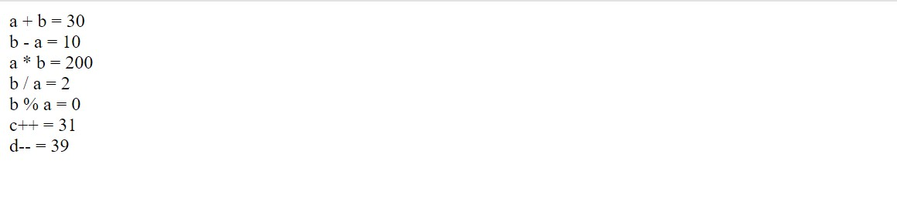

**Comparison operators:**

<!DOCTYPE html>

<html lang="en">

<head>

    <meta charset="UTF-8">

    <meta name="viewport" content="width=device-width, initial-scale=1.0">

    <title>Document</title>

</head>

<body>

    <script>

        let x=5;

        let y=10;

        let z=15;

        document.write("x==y:"+(x==y)+"<br>");

        document.write("y===z:"+(y===z)+"<br>");

        document.write("x!=y:"+(x!=y)+"<br>");

        document.write("x!==y:"+(x!==y)+"<br>");

        document.write("x>y:"+(x>y)+"<br>");

        document.write("z>=y:"+(z>=y)+"<br>");

        document.write("y<x:"+(y<x)+"<br>")

        document.write("x<=y:"+(x<=y));

    </script>

</body>

</html>

Output:

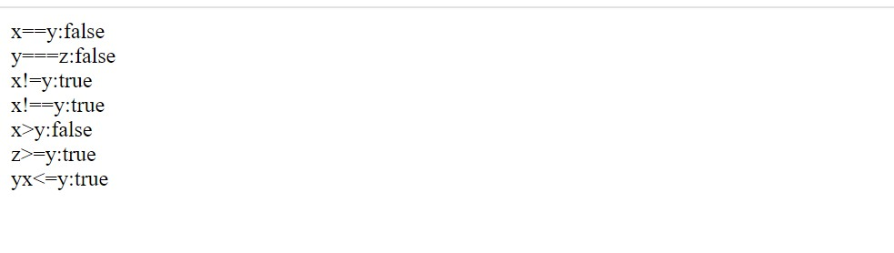

**Bitwise Operators:**

<!DOCTYPE html>

<html lang="en">

<head>

    <meta charset="UTF-8">

    <meta name="viewport" content="width=device-width, initial-scale=1.0">

    <title>Document</title>

</head>

<body>

    <script>

        let a=10;

        let b=20;

        let c=30;

        let d=10;

        document.write("a==b & a==d :"+(a==b & a==d)+"<br>");

        document.write("a==b | a==d :"+(a==b | a==d)+"<br>");

        document.write("a==b ^ a==d :"+(a==b ^ a==d)+"<br>");

        document.write("~a :"+(~a)+"<br>");

        document.write("b<<a :"+(b<<a)+"<br>");

        document.write("b>>a :"+(b>>a)+"<br>");

        document.write("b>>>a :"+(b>>>a));

    </script>

</body>

</html>

Output:

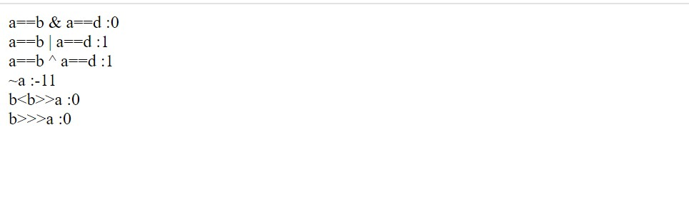

**Logical Operators:**

<!DOCTYPE html>

<html lang="en">

<head>

    <meta charset="UTF-8">

    <meta name="viewport" content="width=device-width, initial-scale=1.0">

    <title>Document</title>

</head>

<body>

    <script>

        let a=20;

        let b=20;

        let c=30;

        document.write("a==b && b==c :"+(a==b && b==c)+"<br>");

        document.write("a==b || b==c :"+(a==b || b==c)+"<br>");

        document.write("!(a==b) :"+(!(a==b)));

    </script>

</body>

</html>

Output:

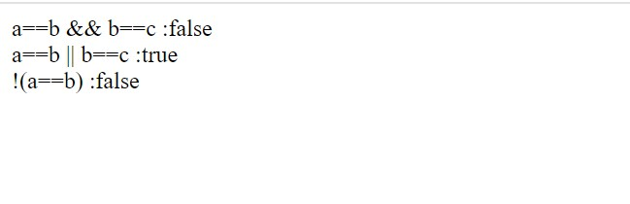

**Assignment Operators:**

<!DOCTYPE html>

<html lang="en">

<head>

    <meta charset="UTF-8">

    <meta name="viewport" content="width=device-width, initial-scale=1.0">

    <title>Document</title>

</head>

<body>

    <script>

        let p=25;

        let q=50;

        let s=10, t=15, u=20, v=22;

        q+=5;

        s-=3;

        t*=2;

        u/=5;

        v%=10;

        document.write("p = :"+p+"<br>");

        document.write("q+=5 :"+q+"<br>");

        document.write("s-=3 :"+s+"<br>");

        document.write("t*=2 :"+t+"<br>");

        document.write("u/=5 :"+u+"<br>");

        document.write("v%=10 :"+v+"<br>");

    </script>

</body>

</html>

Output:

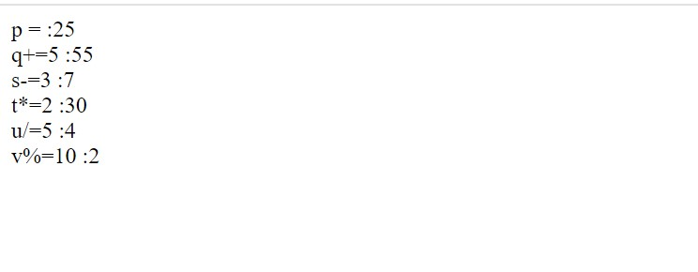

**Special Operators:**

<!DOCTYPE html>

<html lang="en">

<head>

    <meta charset="UTF-8">

    <meta name="viewport" content="width=device-width, initial-scale=1.0">

    <title>Document</title>

</head>

<body>

    <script>

        let x=5;

        let y=15;

        let z=25;

        document.write("(x<y)?'True':'False' :"+(x<y)?"True":"False");

        document.write("<br>");

        document.write(x,y,z);

    </script>

</body>

</html>

Output:

